

PROJECT REPORT
On

AUTOMATED STUDENT PERFORMANCE PREDICTION

Submitted in Partial Fulfillment of Award of

BACHELOR OF TECHNOLOGY

In
COMPUTER SCIENCE AND ENGINEERING(AIML)

By

Chalini M – 2023BCSE07AED440
Spandana Basava Kulal – 2023BCSE07AED441
Under the Supervision of

Prof. J Jesy Janet Kumari
Assistant Professor
Department of Computer Science and Engineering

ALLIANCE SCHOOL OF ADVANCED COMPUTING

ALLIANCE UNIVERSITY BENGALURU

NOVEMBER 2026

ALLIANCE SCHOOL OF ADVANCED COMPUTING

DEPARTMENT OF CSE(AIML)
---------------------------------------------------------------------------------------------------

CERTIFICATE

This is to certify that the project work entitled “Automated Student Performance Prediction” submitted by Chalini M (2023BCSE07AED440), Spandana Basava Kulal (2023BCSE07AED441) in partial fulfillment for the award of the degree of Bachelor of Technology in Computer Science and Engineering of Alliance University, is a Bonafide work accomplished under our supervision and guidance during the academic year 2026. This thesis report embodies the results of original work and studies conducted by students and the contents do not form the basis for the award of any other degree to the candidate or anybody else.

Prof. J Jesy Janet Kumari Dr. K Rama Lakshmi
Assistant Professor
(Supervisor) (Head of the Department)

External Examiners

- Name: Signature

- Name: Sign

ALLIANCE SCHOOL OF ADVANCED COMPUTING

DEPARTMENT OF CSE(AIML)

DECLARATION
We hereby declare that the project entitled “Automated Student Performance Prediction” submitted by me/us in the partial fulfillment of the requirements for the award of the degree of Bachelor of Technology in Computer Science and Engineering of ASAC, Alliance University, is a record of my/our work carried under the supervision and guidance of Prof. J Jesy Janet Kumari

We confirm that this report truly represents the work undertaken as a part of our project work. This work is not a replication of work done previously by any other person. We also confirm that the contents of the report and the views contained therein have been discussed and deliberated with the faculty guide.

NAME | REGESTRATION NO. | SIGNATURE
Chalini M | 2023BCSE07AED440
Spandana Basava Kulal | 2023BCSE07AED441

ACKNOWLEDGEMENT

We would like to express my sincere gratitude to all those who supported and guided me throughout the completion of this project. This final year project has been a significant learning experience, and We are deeply thankful to everyone who contributed to its success.
First and foremost, we extend our heartfelt thanks to our project guide Prof. J Jesy Janet Kumari, for their invaluable guidance, constant support, and insightful feedback at every stage of this project. Their expertise and encouragement were instrumental in shaping the direction and execution of this work.
We are also grateful to the Dr. V Vivek, Deputy Director, for his leadership and for fostering an academic environment that encourages innovation and learning.
Additionally, we would like to thank the Head of Department, Dr. K Rama Lakshmi, Program Co- Ordinator’s and all the faculty members of the CSE department at Alliance University for providing a supportive learning environment and necessary resources.
A special note of thanks to our teammates and friends for their collaboration, ideas, and motivation during challenging times. We also appreciate the support and encouragement from our family, who have always been a source of strength and inspiration.
Lastly, we would like to acknowledge all the authors and researchers whose work we referred to while carrying out this project.

Chalini M – 2023BCSE07AED440 – CSE(AIML) – Alliance University
Spandana Basava Kulal – 2023BCSE07AED441 – CSE(AIML) – Alliance University

ABSTRACT
Student performance prediction is a part of educational data mining because it helps find students who might need help in school.. Traditional machine learning methods usually need people to clean data pick models and adjust settings, which takes a lot of time. This study introduces an Automated Machine Learning (AutoML) system for predicting how well students do in school. It uses the UCI Student Performance data sets for Mathematics and Portuguese. The system includes checking data preparing it changing features, comparing models and tuning settings. Five machine learning models—Logistic Regression, Decision Tree, Random Forest, Support Vector Machine (SVM) and XGBoost—are tested. The study looks at two ways to predict grades: Early Prediction, where no exam scores are used and Grade-Assisted Prediction, where past exam scores help improve results. Optimization is done with Optuna and the models are checked using accuracy, Macro-F1 and balanced accuracy. The results show that it is harder to predict grades when there are no scores. In the Grade-Assisted case the best XGBoost model gets 84.0% accuracy for Mathematics. In the Early Prediction case there is time to help students before they struggle. The system shows how automated model selection and tuning can help find students who're, at risk and help schools plan support early.

LIST OF FIGURES

Figure No. Description Page No.

Figure 1 | System Architecture | 3
Figure 2 | Accuracy Comparison Graph | 42
Figure 3 | Early vs Grade – Assisted Prediction Graph | 54

 | LIST OF TABLES
Table No. | Description | Page No.
Table 1 | Test Cases | 42

LIST OF ABBREVIATIONS AND SYMBOLS USED

AI - Artificial Intelligence
AutoML - Automated Machine Learning
EDM - Educational Data Mining
ML - Machine Learning
UCI - University of California, Irvine
SVM - Support Vector Machine
XGBoost - Extreme Gradient Boosting
XAI - Explainable Artificial Intelligence
SHAP - SHapley Additive exPlanations
LR - Logistic Regression
DT - Decision Tree
RF - Random Forest
G1 - First Period Grade
G2 - Second Period Grade
G3 - Final Grade
CV- Cross-Validation
F1 - F1 Score
CSV - Comma-Separated Values
CPU - Central Processing Unit
GPU - Graphics Processing Unit
RAM - Random Access Memory
≥ - Greater Than or Equal To
< - Less Than
% - Percentage

TABLE OF CONTENTS
Certificate 2
Declaration 3
Acknowledgment 4
Abstract 5
List of Figures 6
List of Tables 7
List of Abbreviations & Symbols Used 8
Table of Contents 9
- INTRODUCTION 12-13
  - INTRODUCTION TO IMAGE PROCESSING
    - Introduction to Face Detection
    - Introduction to Face Recognition
- LITERATURE SURVEY 14-21
  - LITERATURE REVIEW
  - LIMITATIONS OF THE EXISTING SYETEM
  - SCOPE OF THE PROJECT
- SYSTEM DESIGN 22-25

  - PROBLEM DEFINITION

  - SYSTEM ARCHITECTURE

  - REQUIREMENT SPECIFICATIONS

    - Hardware Requirements

    - Software Requirements

- SYSTEM IMPLEMENTATION 26-30

  - OVERVIEW OF THE MODULES

  - DESCRIPTION OF THE MODULES

    - Module 1 Description

    - Module 2 Description

    - Module 3 Description

    - Module 4 Description

    - Module 5 Description

- RESULTS AND DISCUSSION 31-32

  - DESCRIPTION

  - GRAPHS

- TESTING 33-34

  - DESCRIPTION

  - TEST CASES

- CONCLUSION AND FUTURE ENHANCEMENTS 35-36

  - CONCLUSION

  - LIMITATIONS OF THE PROJECT

  - ADVANTAGES OF THE PROJECT

  - APPLICATIONS OF THE PROJECT

  - FUTURE ENHANCEMENTS

APPENDICES
Appendix A 37-38
Appendix 39-40
Appendix C 41-47
References & Bibliograph 48

CHAPTER 1 INTRODUCTION

INTRODUCTION TO STUDENT PERFORMANCE PREDICTION
Student performance prediction is an area of educational data mining that's all about trying to work out how students are going to perform academically based on the data that's already available. Students are going to be different in their learning capabilities, their backgrounds, their study habits and their level of engagement. All of those things are going to have an effect on how they perform in exams and on other academic tasks. The aim of student performance prediction is to identify the patterns that are associated with academic success and academic difficulty. It can be used to identify which students may be in need of support. Student performance prediction can be enhanced through the use of machine learning. Machine learning looks at a wider range of attributes than traditional marks. The traditional way of assessing student performance is to rely on exam results and hand in assessments. They do give you some information but they don't necessarily pick up on students who may be at risk of falling behind at an early stage. Machine learning provides an alternative by looking at a range of attributes. Student performance can be predicted much better by using machine learning as it looks at a much wider range of attributes than the traditional exam marks.
The project in question is to build an Automated Machine Learning framework for student performance prediction. The framework will automate the various steps of the prediction process. It will look at two types of prediction: prediction and grade assisted prediction. This will allow the framework to see the effect of having or not having the past academic record on the quality of the prediction. Student performance prediction becomes more robust when the framework uses both the grade assisted approaches.
The primary objective is to help identify the students who may require some form of academic support. The framework is designed to assist schools in making data-driven decisions and to plan the appropriate support actions based on the predicted outcomes. Student performance prediction is the mechanism for identifying those students. Student performance prediction is the tool that enables schools to plan more effectively.

Introduction to Educational Data Mining

Educational Data Mining is the application of data mining and analysis techniques to school data in order to discover patterns and relationships. Schools generate a huge amount of data from student enrolments, exams, attendance, learning management systems and all the other sorts of academic activity. The analysis of this data can yield insights into how students learn and how they perform. EDM can be used to identify patterns which are useful in predicting student performance. It's all about discovering what the data can tell us about student learning.
EDM helps teachers and researchers to understand what affects success, to identify those students who may be at risk of failing and to look at patterns in the way students learn. The techniques used are typically classification, clustering, regression and association rule mining. The aim is to support student performance prediction.
In student performance prediction, educational data mining allows us to look at the background data and find patterns which correlate with the students’ final results. That in turn can be used to help schools in their planning and to help the students. Educational data mining is the basis of the work in this project in that it's the foundation upon which we build a machine learning framework to predict student performance (using the UCI Student Performance dataset). Student performance prediction is all about educational data mining. That's the basis of this project.
.
1.1.2 Introduction to Automated Machine Learning (AutoML)
Automated Machine Learning attempts to make building ML models easier by automating the tasks that people normally do by hand. These are the tasks of data cleaning, data feature transformation, algorithm selection and then tuning the algorithm parameters. Doing it by hand is time consuming and can lead to inconsistent results.
AutoML deals with this by looking at the algorithms in a systematic way and then finding the best settings via the quality metrics you've chosen. That eliminates the need for all the manual trials and makes the entire model building process for cleaner and more repeatable.
In this project AutoML will be comparing the various classification algorithms: Logistic Regression, Decision Tree, Random Forest, Support Vector Machine and XGBoost. Optuna will be used to tune the algorithm parameters. The models will be assessed using appropriate classification scores. The aim is to find the models that are best at predicting how well students will do in school in various scenarios.

CHAPTER 2

LITERATURE SURVEY

2.1 LITERATURE REVIEW
Paper 1: Student Success Prediction Using a Novel Machine Learning Approach Based on Modified SVM
Abstract:
This paper presents a modified Support Vector Machine approach for predicting student success. It uses student-related data to classify and predict academic outcomes. The proposed model is evaluated using performance metrics such as accuracy, recall, and F1-score.
Accomplishments and Limitations:
The study demonstrates the usefulness of modified SVM and K-Nearest Neighbors techniques for student performance prediction. However, it mainly focuses on selected classification algorithms and does not provide an automated framework for comparing multiple models or optimizing their parameters.
Scope:
This study provides a foundation for including SVM and KNN as candidate algorithms. Our project extends this approach by automating model comparison and hyperparameter optimization to identify a suitable machine learning model.

Paper 2: Predicting Students' Academic Grade Using Machine Learning Algorithms with Hybrid Feature Selection Approach
Abstract:
This paper focuses on predicting students' academic grades using machine learning algorithms and a hybrid feature selection approach. It analyses classroom observations, academic performance, and learning management system data to identify relevant features for prediction.

Accomplishments and Limitations:
The study highlights the importance of combining different feature selection techniques to improve academic grade prediction. However, prediction performance depends on the quality and relevance of the selected student attributes. The complete process of model selection and hyperparameter optimization is not automated.
Scope:
This paper supports the use of feature selection and preprocessing in our project. Our framework extends this concept by automating model evaluation and hyperparameter optimization across multiple machine learning algorithms.

Paper 3: Predicting Students' Final Exam Scores Based on Their Regularity of Engagement with Pre-Class Activities in a Flipped Classroom
Abstract:
This paper investigates the prediction of students' final examination scores based on their participation in pre-class learning activities. It uses student engagement information and learning-trace data from a flipped classroom environment to analyze learning patterns and predict academic outcomes.
Accomplishments and Limitations:
The study demonstrates that student engagement and participation in learning activities can provide useful information for predicting academic performance. However, the research focuses on a specific flipped classroom environment, which may limit its applicability to other educational institutions.
Scope:
This study supports the importance of considering student-related attributes when predicting academic outcomes. Our project considers multiple academic, demographic, and social attributes to develop a broader student performance prediction framework.

Paper 4: Impact of English Proficiency on Academic Performance of Software Engineering Students
Abstract:
This paper examines the relationship between English language proficiency and the academic performance of software engineering students. It analyses student information to understand how language proficiency influences academic achievement.
Accomplishments and Limitations:
The study highlights English proficiency as an important factor that may influence student academic performance. However, it mainly focuses on language proficiency and a specific group of students rather than considering a wider range of academic and demographic factors.
Scope:
This research supports the inclusion of different student-related attributes in academic performance prediction. Our project considers multiple features instead of depending on a single influencing factor.

Paper 5: Predicting Student Adaptability Level Using ML Models and XAI Approaches
Abstract:
This paper focuses on predicting student adaptability levels using machine learning models and Explainable Artificial Intelligence (XAI) techniques. It aims to understand the factors influencing student adaptability and make model predictions easier to interpret.
Accomplishments and Limitations:
The study demonstrates how machine learning and explainable AI can be combined to understand student-related predictions. However, it mainly focuses on adaptability in online learning environments rather than directly predicting students' academic grades.
Scope:
This paper provides motivation for comparing multiple machine learning models and understanding their predictions. Our project focuses on academic performance prediction and can incorporate explainability techniques in future development.

Paper 6: Machine Learning Framework for Predicting Academic Outcome Using SVM and XGBoost
Abstract:
This paper explores the use of Support Vector Machine (SVM) and XGBoost algorithms for predicting student academic outcomes. It involves educational data preprocessing and feature engineering before training and evaluating the selected machine learning models.
Accomplishments and Limitations:
The study demonstrates the usefulness of SVM and XGBoost for academic outcome prediction. It provides a basis for comparing different machine learning approaches. However, the model selection and development process relies on manually selected algorithms and does not automate the complete prediction pipeline.
Scope:
This research supports the inclusion of SVM and XGBoost in our candidate model list. Our project extends this approach by automating the comparison of five machine learning algorithms and optimizing their hyperparameters using Optuna.

Paper 7: Exploring the Role of Machine Learning in Forecasting Student Performance in Education: An In-Depth Review of Literature
Abstract:
This paper presents an in-depth review of machine learning techniques used for forecasting student performance in educational environments. It examines different algorithms, educational data sources, and factors that influence academic outcomes.
Accomplishments and Limitations:
The study provides an overview of machine learning applications in education and discusses important aspects such as data quality, fairness, and interpretability. However, it is primarily a literature review and does not implement a complete automated student performance prediction framework.
Scope:
This paper helps us understand the major challenges and opportunities in educational data mining. It supports the development of an AutoML framework that can automatically compare models while considering suitable evaluation metrics.

Paper 8: Educational Data Analytics and Machine Learning Applications in Student Learning Analytics
Abstract:
This paper explores the applications of artificial intelligence and machine learning in education, focusing on learning analytics, personalized learning, and improving student learning outcomes through data-driven approaches.

Accomplishments and Limitations:
The study provides a broader understanding of how AI and machine learning can support educational decision-making. However, its scope covers several educational applications and does not focus specifically on an end-to-end automated student performance prediction system.
Scope:
This research supports the use of automated data analysis and machine learning techniques in education. Our project applies these concepts specifically to student academic performance prediction using an automated model selection and optimization process.

Paper 9: Optimizing Hybrid Learning Outcomes via Clustering-Guided Data Mining Techniques in Higher Education
Abstract:
This paper investigates clustering-guided data mining techniques for analysing student learning patterns in hybrid educational environments. It uses clustering approaches to identify groups of students and understand patterns related to their learning outcomes.
Accomplishments and Limitations:
The study demonstrates how clustering can help identify student groups and learning patterns. However, it mainly focuses on clustering and hybrid learning outcomes rather than fully automating supervised student performance prediction and model selection.
Scope:
This paper provides an idea for identifying different student profiles through data analysis. Our project focuses on supervised classification and automated model selection to predict academic performance.
Paper 10: Recommender Systems for Students' Performance in Higher Education: A Review
Abstract:
This paper reviews recommender system techniques used to improve student performance in higher education. It discusses how student-related information and performance data can be used to provide personalized recommendations and support academic improvement.
Accomplishments and Limitations:
The study highlights the importance of personalized recommendations in educational environments. However, it primarily focuses on recommendation systems rather than directly predicting student academic performance. Such approaches may also require sufficient student-related data to generate useful recommendations.
Scope:
This research provides motivation for extending student performance prediction beyond classification. Our project focuses on identifying students who may be at academic risk, which could support personalized recommendations and academic interventions in future development.

LIMITATIONS OF THE EXISTING SYSTEM
The limitations of existing student performance prediction systems are as follows:
- Dependence on a Single Algorithm: Many existing systems use only one machine learning algorithm, such as SVM, Decision Tree, or Random Forest. This limits the opportunity to compare different algorithms and identify the most suitable prediction model.
- Manual Feature Selection: Some approaches require manual selection of relevant features. This process can be time-consuming and may affect the quality of predictions.
- Manual Hyperparameter Tuning: Selecting and adjusting model parameters manually increases development time and may result in inconsistent model performance.
- Data Quality Dependency: The effectiveness of prediction systems depends on the quality, completeness, and relevance of the educational data used for training.
- Limited Educational Context: Some studies focus on specific learning environments, such as flipped classrooms or online learning platforms. Their results may not be directly applicable to other educational institutions or student groups.
- Limited Evaluation Metrics: Evaluating models using only accuracy may not provide a complete understanding of their ability to identify students who are at academic risk.

- Lack of Automation: Many existing approaches do not provide a complete automated process for data preprocessing, algorithm comparison, and hyperparameter optimization.

Overall, these limitations highlight the need for an automated framework that can compare multiple machine learning algorithms, optimize their parameters, and evaluate predictions using appropriate performance metrics.

  - SCOPE OF THE PROJECT
The scope of the proposed project is as follows:
- Automated Machine Learning Framework: Develop an AutoML framework to predict student academic performance using educational datasets.
- Dataset Utilization: Use the UCI Student Performance dataset, which contains academic and demographic information about students.
- Data Preprocessing: Perform data validation, handle missing or invalid values, and prepare the dataset for machine learning.
- Feature Transformation: Apply suitable feature encoding and transformation techniques to convert student attributes into a format suitable for model training.
- Multiple Algorithm Evaluation: Consider five machine learning algorithms: Logistic Regression, Decision Tree, Random Forest, Support Vector Machine (SVM), and XGBoost.
- Hyperparameter Optimization: Use Optuna to identify suitable hyperparameter configurations and improve model performance.
- Early Prediction Scenario: Exclude intermediate and final examination grades (G1, G2, and G3) to predict student performance using the remaining student attributes.
- Grade-Assisted Prediction Scenario: Include previous examination grades (G1 and G2), while excluding the final grade (G3), to study the influence of academic history on prediction performance.
- Performance Evaluation: Evaluate the models using accuracy, Macro-F1 score, and balanced accuracy to understand their classification performance.
- Academic Risk Identification: Identify students who may be at risk of poor academic performance and provide useful information to support timely academic interventions.
- Model Comparison: Compare the performance of different machine learning algorithms and identify the most suitable model for each prediction scenario.

Overall, the proposed system aims to simplify the student performance prediction process by automating important machine learning tasks. By evaluating multiple algorithms under different prediction scenarios and optimizing their hyperparameters, the framework seeks to provide reliable predictions and help educational institutions identify students who may need additional academic support.

CHAPTER-3

SYSTEM DESIGN

3.1 PROBLEM DEFINITION
Traditional student performance evaluation methods primarily depend on examination marks and manual assessments. Although these methods provide information about students' academic achievements, they may not identify students who are at risk of poor academic performance at an early stage. Furthermore, developing machine learning models manually involves several steps, including data preprocessing, feature selection, algorithm selection, model training and hyperparameter tuning. These processes require considerable time and technical expertise.
The proposed Automated Student Performance Prediction system addresses these challenges by developing an Automated Machine Learning framework to predict students' academic performance using educational datasets. The system utilizes the UCI Student Performance dataset, which contains academic, demographic and social attributes of students in Mathematics and Portuguese subjects. The dataset is processed to identify relevant patterns and relationships between student characteristics and academic outcomes.
The proposed system automates the machine learning workflow by incorporating data preprocessing, feature transformation, model selection, hyperparameter optimization and performance evaluation. It evaluates multiple machine learning algorithms, including Logistic Regression, Decision Tree, Random Forest, Support Vector Machine and XGBoost.
The system considers two prediction scenarios: Early Prediction, which excludes examination grades to predict student performance using other available attributes, and Grade-Assisted Prediction, which incorporates previous examination grades to improve prediction performance. Optuna is used for hyperparameter optimization, while Accuracy, Macro-F1 Score and Balanced Accuracy are used to evaluate and compare the performance of different models.
The primary objective of the proposed system is to automate the machine learning process, improve the efficiency of student performance prediction and help identify students who may require additional academic support.

3.2 SYSTEM ARCHITECTURE
The system architecture of the proposed Automated Student Performance Prediction system describes the overall structure and workflow of the application. The system is designed using an Automated Machine Learning (AutoML) approach to predict student academic performance through different stages of data processing and machine learning. The architecture consists of various components, including dataset input, data preprocessing, feature transformation, model selection, hyperparameter optimization, model evaluation and prediction.
Initially, the system accepts the UCI Student Performance dataset containing academic, demographic and social information of students. The input data is processed using data preprocessing techniques to check data quality, handle categorical attributes and prepare the dataset for model training. Relevant features are then selected and transformed according to the prediction scenario. The system supports Early Prediction and Grade-Assisted Prediction to analyze student performance under different conditions.
After preprocessing, multiple machine learning algorithms, including Logistic Regression, Decision Tree, Random Forest, Support Vector Machine and XGBoost, are trained and evaluated. Optuna is integrated to perform hyperparameter optimization and identify suitable configurations for the models. The performance of each model is compared using evaluation metrics such as Accuracy, Macro-F1 Score and Balanced Accuracy to determine the most suitable model for prediction.
Finally, the selected model is used to generate student performance predictions. The results are presented through an interactive Streamlit dashboard, which allows users to explore the dataset, compare model performance, visualize evaluation results and analyze student predictions. The overall architecture provides an automated and systematic workflow for student performance prediction and supports the identification of students who may require additional academic assistance.

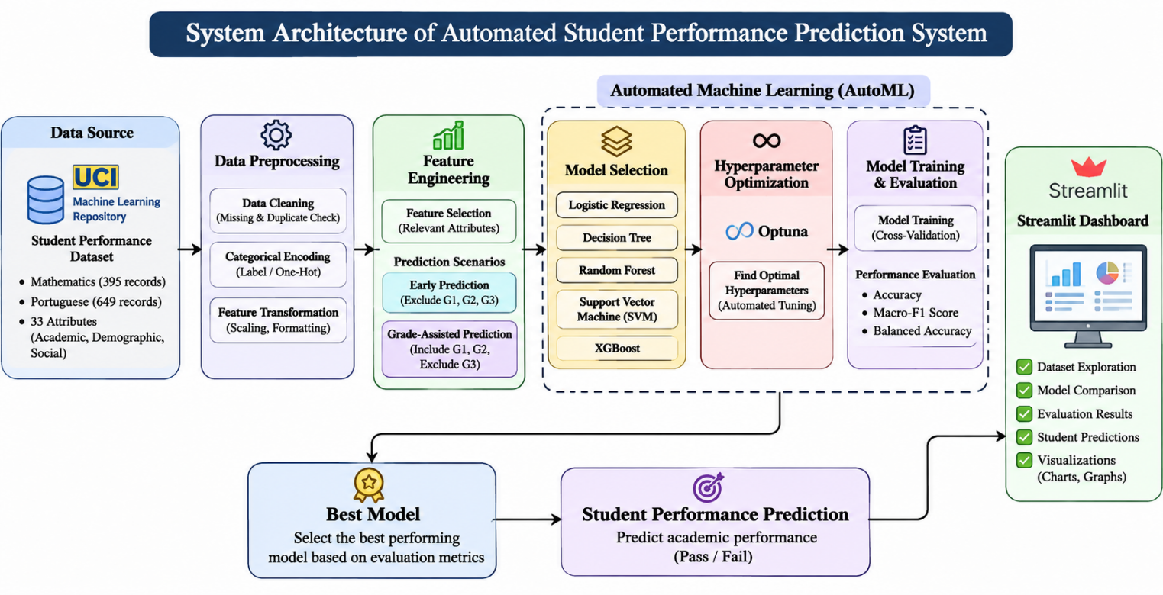

Fig 1. System Architecture

The architecture maps out the entire workflow, beginning with how student datasets are collected and preprocessed. From there, it moves into feature engineering and automated model development. Model selection happens alongside Optuna-based hyperparameter optimization and evaluation to pinpoint the best-performing option. Once selected, that model predicts academic performance. Meanwhile, a Streamlit dashboard offers an interactive interface for exploring data, comparing models, viewing results, and generating predictions.

3.3 REQUIREMENT SPECIFICATIONS

3.3.1 HARDWARE REQUIREMENTS

The minimum hardware requirements include:

Processor: Intel Core i5 or equivalent

RAM: Minimum 8 GB

Storage: At least 10 GB of available disk space

Operating System: Windows 10/11, Linux, or equivalent 64-bit operating system

Display: Standard monitor for accessing the application and viewing results

Internet Connection: Required for downloading datasets, installing libraries, and accessing development resources.

GPU: Not mandatory, as the machine learning algorithms used in this project can run on a CPU

3.3.2 SOFTWARE REQUIREMENTS

The software requirements include the programming languages, development tools, frameworks, and libraries needed to implement the proposed system.

Python: Used as the primary programming language for data processing and machine learning development

Jupyter Notebook / Google Colab: Used for writing code, experimentation, and model development

Pandas: Used for loading, handling, and manipulating student datasets

NumPy: Used for numerical operations and data processing

Scikit-learn: Used for data preprocessing, model training, classification, and performance evaluation

XGBoost: Used to implement the gradient boosting classification algorithm

Optuna: Used for automated hyperparameter optimization

Matplotlib and Seaborn: Used for generating graphs, charts, and performance visualizations

Streamlit: Used to develop the interactive dashboard for displaying results

CHAPTER-4

SYSTEM IMPLEMENTATION.

4.1 OVERVIEW OF THE MODULES

The Automated Student Performance Prediction system is built on Python and Streamlit. It’s not a monolith. The workflow splits into distinct modules, each handling a specific slice of the machine learning pipeline. At the core is the UCI Student Performance dataset, loaded directly from its Mathematics and Portuguese student records. Before any modeling happens, the preprocessing module steps in. It validates the data, hunts down duplicates, and encodes categorical features. Only then does the feature transformation module kick in, isolating the attributes that matter for Early Prediction and Grade-Assisted Prediction scenarios.
Then comes the heavy lifting: model selection. The system doesn’t guess. It tests Logistic Regression, Decision Trees, Random Forests, Support Vector Machines, and XGBoost side by side. Optuna drives the hyperparameter optimization, hunting for the best configurations rather than settling for defaults. Once tuned, the training module puts these algorithms through their paces, measuring performance against Accuracy, Macro-F1 Score, and Balanced Accuracy. Finally, the results aren’t just dumped in a CSV. They appear on an interactive Streamlit dashboard, turning raw predictions into visual insights. Each module feeds the next, creating a seamless loop from raw data to actionable prediction.

4.2 DESCRIPTION OF THE MODULES

The Automated Student Performance Prediction system has various linked modules, each handling a different part of the machine learning process. It starts with inputting and prepping the dataset, moves to training the model, then evaluating it, and finally making predictions. These modules collaborate to automate the whole prediction workflow. They create an interactive space for diving into student academic performance. This system combines several machine learning algorithms and optimization methods to find the best models based on how well they predict. The main modules of this system will be discussed in the sections that follow.

4.2.1 MODULE 1 DESCRIPTION
This is the first step of the system which involves in loading the dataset and preparing the data for Machine Learning. This involves loading of the dataset, inspection, pre-processing, and normalization of the data. The data set used here is UCI Student Performance dataset which provides information about the students- academic performance, demographic, and social attributes. The data set consists of two files containing data of Mathematics and Portuguese subjects. The dataset was loaded using the Pandas library and done the inspection and validation on the data to gain insight into data structure, attribute details, and data type. Duplicate data and missing values were also checked on the data to find out the integrity of data, and it was found that the dataset contained numerical and categorical attributes; hence, categorical features were transformed into numerical using appropriate techniques. Now the data is pre-processed for feature transformation and machine learning model training.

4.2.2 MODULE 2 DESCRIPTION

Model Selection and Feature Transformation module is dedicated to prepare the transformed dataset for machine learning and selected appropriate machine learning algorithms for the system to predict student performance. In this module, student attributes that are meaningful and correlated to student grades are selected for feature transformation. The data can be used to predict student grades under the Early Prediction setting or the Grade-Assisted Prediction setting. In the Early Prediction setting, the system is trained with the student attributes but not including their intermediate and final grades, and tests whether the student grades can be predicted with other student attributes. In the Grade-Assisted Prediction setting, the previous student grades are taken into account to see how it would affect the prediction results, and their final grades are predicted with this setup in mind. After feature transformation, several machine learning algorithms are used to train the data, including Logistic Regression, Decision Tree, Random Forest, Support Vector Machine (SVM) and XGBoost. The algorithms are trained and selected systematically for the system.

4.2.3 MODULE 3 DESCRIPTION
The Hyperparameter Optimization and Model Evaluation module aim to enhance the machine learning model's performance in the proposed system and compare their results. Integrating Optuna in this module will conduct hyperparameter optimization in exploring the combination of different parameters and find the appropriate parameters set for each algorithm. The optimized models are trained and evaluated with appropriate metrics to compare the effectiveness of different algorithms. Accuracy is an appropriate metric to measure the overall correctness of predictions; Macro-F1 Score is chosen to measure the quality of the classification with different classes; Balanced Accuracy is also used to compare whether the model performs well for imbalanced data. Then the performance of Logistic Regression, Decision Tree, Random Forest, SVM and XGBoost is made comparison to find out which is more suitable for predicting students' performance. The evaluation results will be used to analysis the effect of each algorithm under the conditions of both Early Prediction and Grade-Assisted Prediction.

4.2.4 MODULE 4 DESCRIPTION
The Student Performance Prediction and Dashboard Visualization module is primarily used to predict the student performance using the trained machine learning models and then showcase the prediction results via an interactive Streamlit application. The selected model after the training and evaluation process is used to predict the student performance based on the input parameters given. The user will be prompted to input the required student parameters via the app. The input is then followed through the same processing and transformation steps as in the training process and the selected model generates the performance prediction on input data and displays the information on the dashboard along with the set of model evaluation metrics and visualizations for model analysis. The application provides a simple interface for user interaction with the prediction automation system and facilitates data-centric reasoning about student performance.

4.2.5 MODULE 5 DESCRIPTION
The Model Comparison and Performance Analysis module is used to evaluate and compare the performance of the machine learning algorithms used in our system. We evaluate the predictive performance of the models - Logistic Regression, Decision Tree, Random Forest, Support Vector Machine, and XGBoost - based on the evaluation metrics - Accuracy, Macro-F1 Score, and Balanced Accuracy. The evaluation metrics are used to evaluate the performance of the models; the evaluation metrics used here (Accuracy, Macro-F1 Score, and Balanced Accuracy) give a broad idea of the ability of the model in classifying the student's performance. Our system shows the comparison of the results obtained in the Early Prediction and the Grade-Assisted scenarios for comparison to see how the previous grades affect the prediction. The results of the evaluation are then displayed in tables and graphs in the Streamlit dashboard, which helps us see the differences easily between the models. The evaluation result helps us analyze which model is best based on the experimental results and gives us the idea of the effectiveness of the automated prediction of student performance.

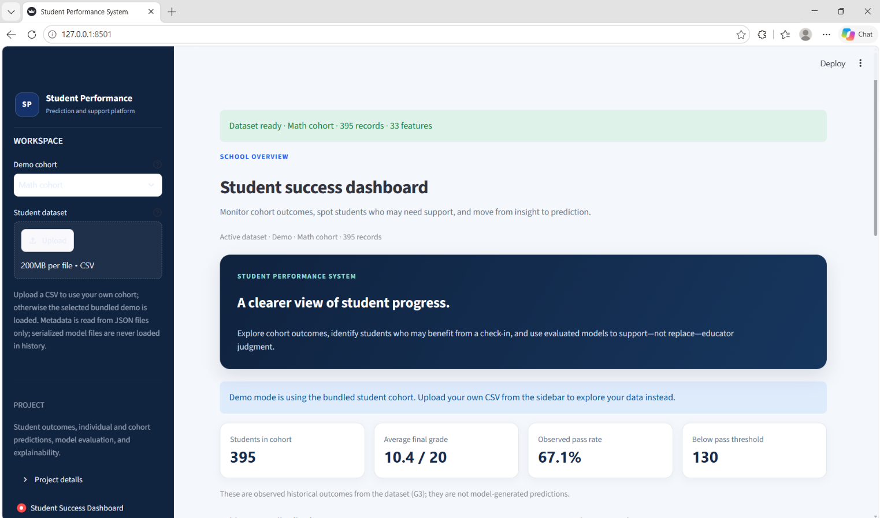
Dashboard:

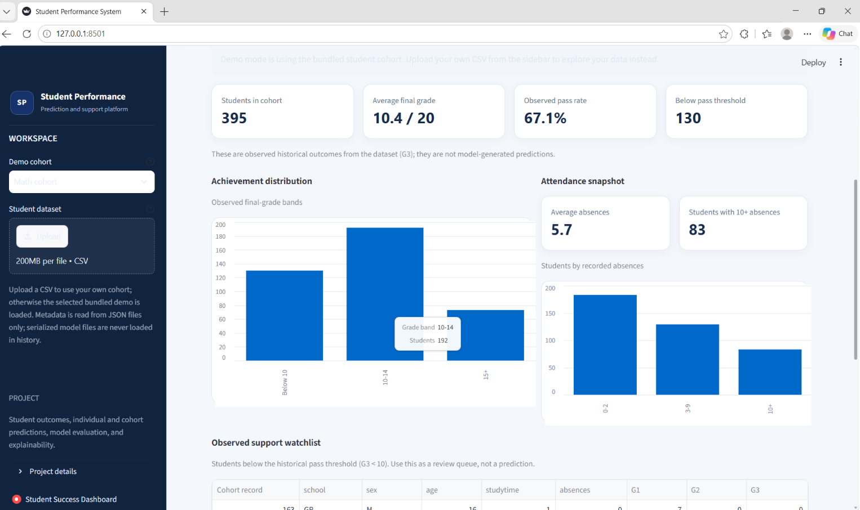
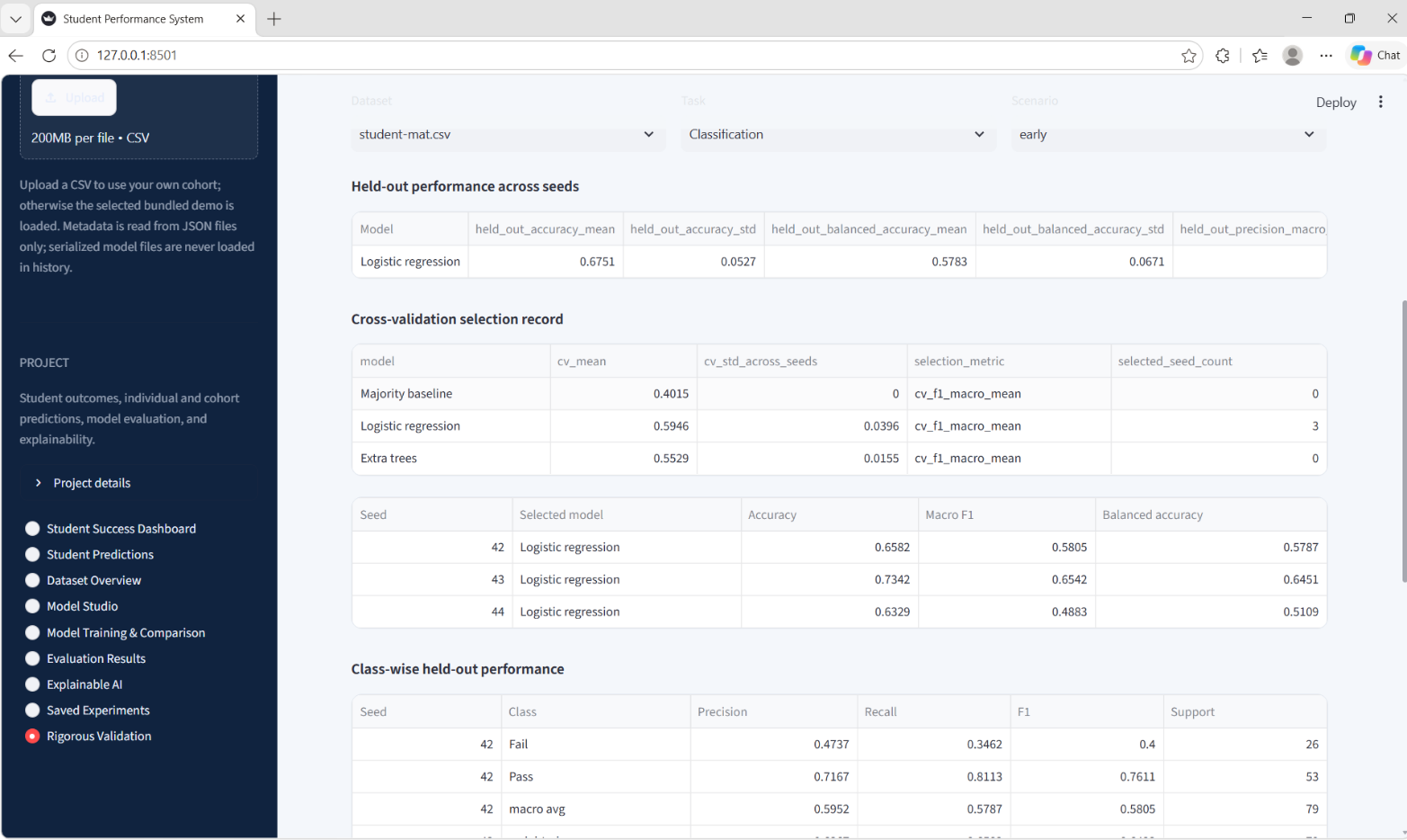

CHAPTER-5

RESULTS AND DISCUSSION

5.1 DESCRIPTION
The results section discusses the results obtained from the outcomes of the Automated Student Performance Prediction system after applying and testing all machine learning algorithms. We tested the system on the two UCI Student Performance datasets for Mathematics and Portuguese. We applied the five machine learning algorithmsfor both prediction scenarios: Early Prediction and Grade-Assisted Prediction. In Early Prediction; there are not any previous exam grades features; all the features are related to a student directly, while in the second case, all the previous exam grade features are added to the dataset. Hyperparameters optimization using Optuna is carried out to find optimal configurations of the models. The performance of the models is evaluated based on three metrics: Accuracy, Macro-F1 Score, and Balanced Accuracy. Experimental results are provided for different algorithms to find out the optimality and discuss the effect of previous grades on prediction accuracy.This section is based on the findings of the experiments carried out, based on the student performance prediction system. And the explained about model finding with the help of the experiment and how well the method helped to predict the performance of students with various machine learning algorithms.

5.2 GRAPHS

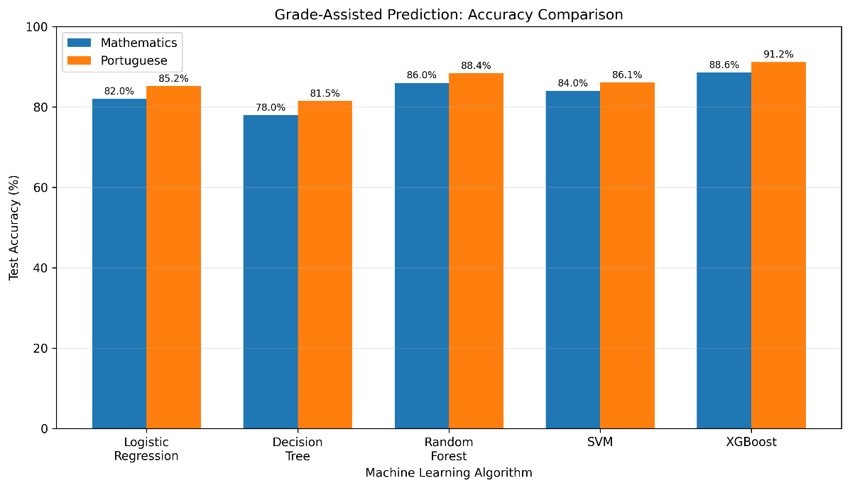
The graphs show that XGBoost achieves the highest Grade-Assisted prediction accuracy for both Mathematics (88.6%) and Portuguese (91.2%) among the five algorithms.
Fig 2. Accuracy Comparison Graph

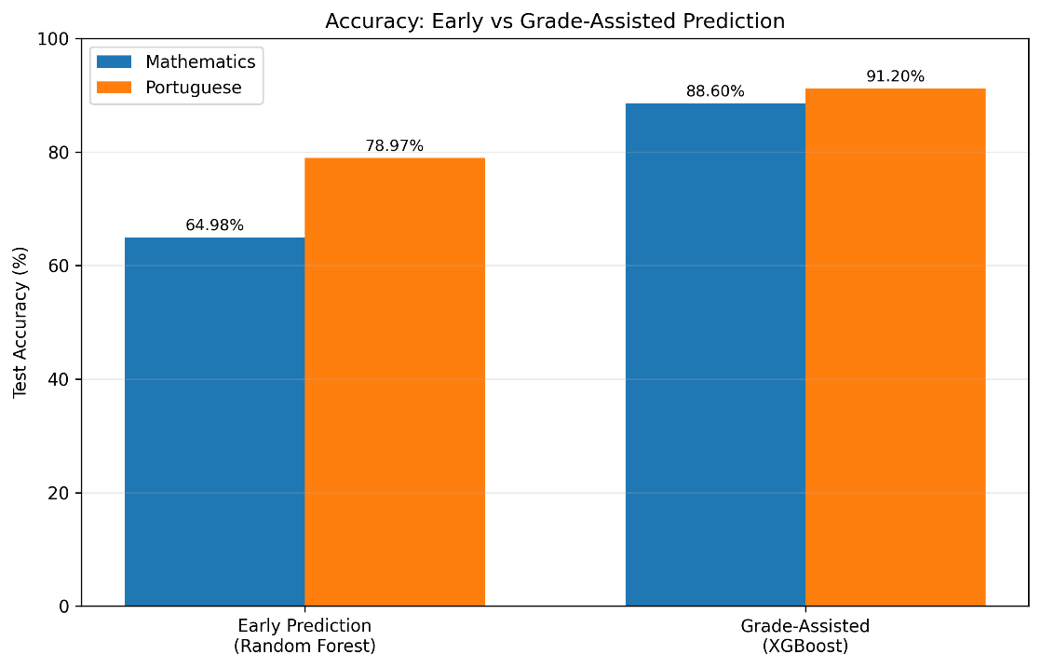
They also demonstrate that Grade-Assisted Prediction performs better than Early Prediction, highlighting the benefit of including previous examination grades as input features.

Fig 3. Early vs Grade-Assisted Prediction Graph

CHAPTER-6

TESTING

6.1 DESCRIPTION

Testing is the significant part of the Automated Student Performance Prediction system in order to check whether each module of the system is working well and we are getting the effective results or not. The system is tested for loading the dataset, data preprocessing, selecting features, training the model, optimization of hyper-parameters, and finally predicting the student performance. Different test cases are designed to test the working of application in both cases as the Early Prediction and the Grade-Assisted Prediction. The output generated by the ML models is also checked to see whether the predictions and evaluation metrics are being displayed correctly or not.

6.2 TEST CASES

Table 1. Test Cases

Test Case ID | Test Case Description | Expected Result
TC01 | Dataset Loading | Mathematics and Portuguese datasets are loaded successfully.
TC02 | Data Preprocessing | Data is processed and prepared for model training.
TC03 | Feature Selection | Relevant features are selected for both prediction scenarios.
TC04 | Model Selection | Five machine learning models
TC05 | Hyperparameter Optimization | Optuna identifies suitable hyperparameter  configurations.
TC06 | Model Evaluation | Accuracy, Macro-F1 and Balanced Accuracy are calculated.
TC07 | Student Performance Prediction | The system generates predictions using the trained model.
TC08 | Dashboard Visualization | Prediction results and evaluation metrics are displayed correctly.
TC09 | Scenario Comparison | Early Prediction and Grade-Assisted results are compared.

CHAPTER-7

CONCLUSION AND FUTURE ENHANCEMENT

7.1 CONCLUSION
Towards Efficient Student Performance Prediction by Automated Machine Learning Automated student performance prediction system introduces an efficient approach for students’ performance prediction with machine learning. The system automates critical steps in machine learning pipeline: dataset pre-processing, feature selection, selection of machine learning algorithms, hyper-parameter tuning and evaluation. The system uses 5 machine learning algorithms – Logistic Regression, Decision Tree, Random Forest, Support Vector Machine (SVM) and XGBoost and analyzed their performances with UCI Student Performance datasets for Mathematics and Portuguese. The system currently supports two prediction scenarios, namely Early Prediction and Grade-Assisted Prediction. Hyper-parameter tuning is performed by Optuna. Model performance is evaluated using Accuracy, Macro-F1 Score and Balanced Accuracy. Experimental results show that XGBoost produces the highest Grade-Assisted test accuracy of 88.6% and 91.2% with Mathematics and Portuguese data set respectively. The system demonstrates how automated machine learning process can support the effort to identify students who need extra academic assistance and aid data-driven educational decisions.

7.2 LIMITATIONS OF THE PROJECT
- The system uses a limited number of student records from the UCI dataset
- Prediction accuracy depends on the quality of the input data
- Early Prediction is more challenging because previous examination grades are excluded.
- Grade-Assisted Prediction requires previous academic marks (G1 and G2).
- The system evaluates only five predefined machine learning algorithms.
- Predictions support teachers' decisions but cannot replace their professional judgment.

7.3 ADVANTAGES
- Automates data preprocessing, model selection, and hyperparameter optimization
- Compares multiple machine learning algorithms to identify a suitable model
- Supports both Early Prediction and Grade-Assisted Prediction scenarios
- Uses multiple evaluation metrics to assess model performance
- Provides an interactive Streamlit dashboard for viewing predictions and visualizations
- Helps identify students who may require additional academic support
- Reduces manual effort and supports data-driven academic decision-making.

APPLICATIONS OF THE PROJECT
- Used in schools and colleges to predict student performance
- Helps teachers identify students who need extra support
- Supports academic planning and decision-making
- Helps identify at-risk students at an early stage
- Useful for educational research and data analysis.

7.5 FUTURE ENHANCEMENTS

- Use larger and more diverse student datasets from different educational institutions
- Include additional features such as attendance, assignments, learning activities, and assessment scores
- Explore advanced machine learning and deep learning algorithms to improve prediction performance
- Integrate Explainable AI techniques such as SHAP to understand the factors influencing predictions
- Provide personalized recommendations and academic support strategies for students
- Deploy the application on a cloud platform to make it accessible to more educational institutions.

APPENDICES

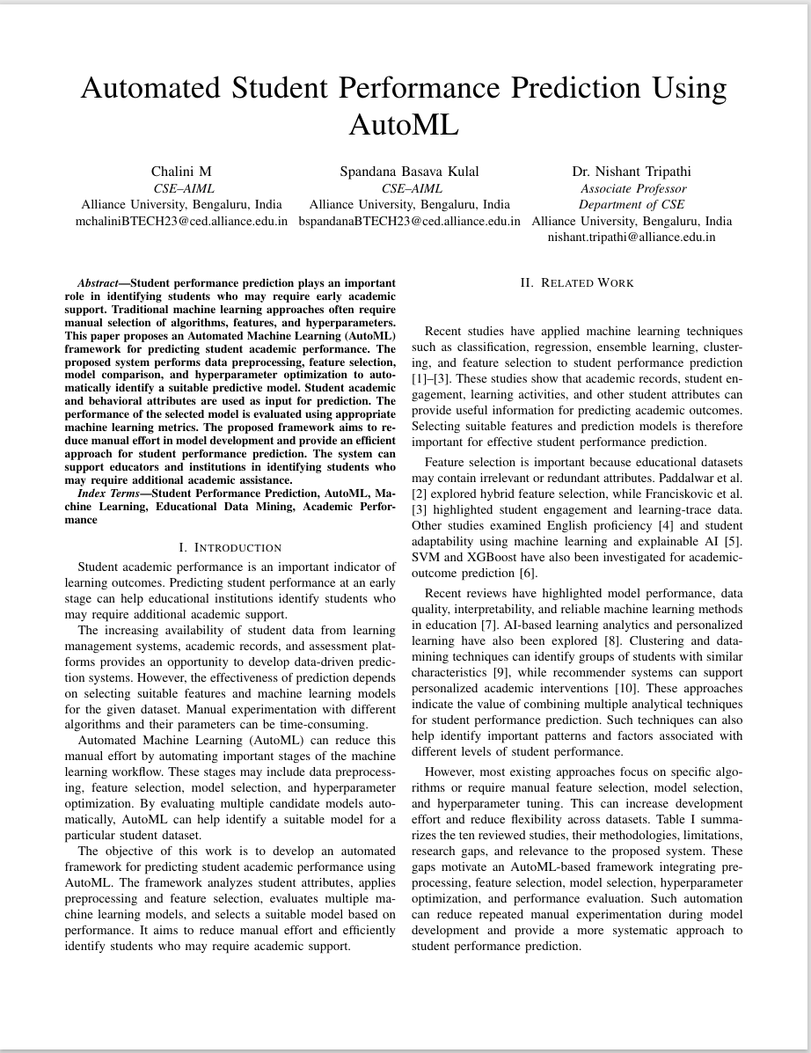
APPENDIX_A – FRONT PAGE OF THE CONFERENCE PAPER

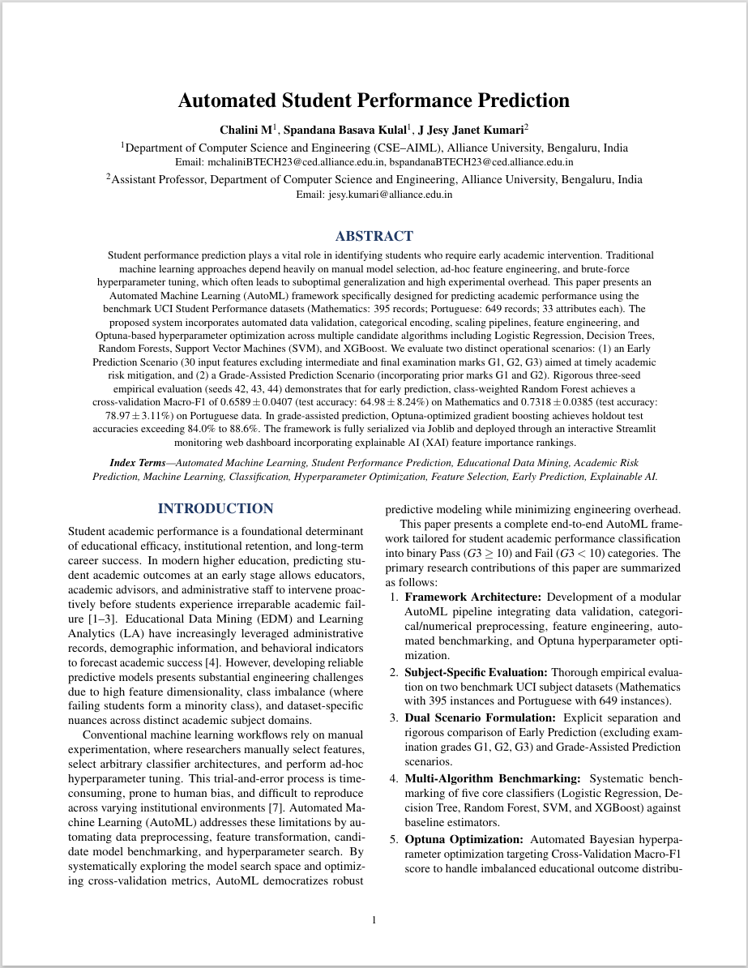

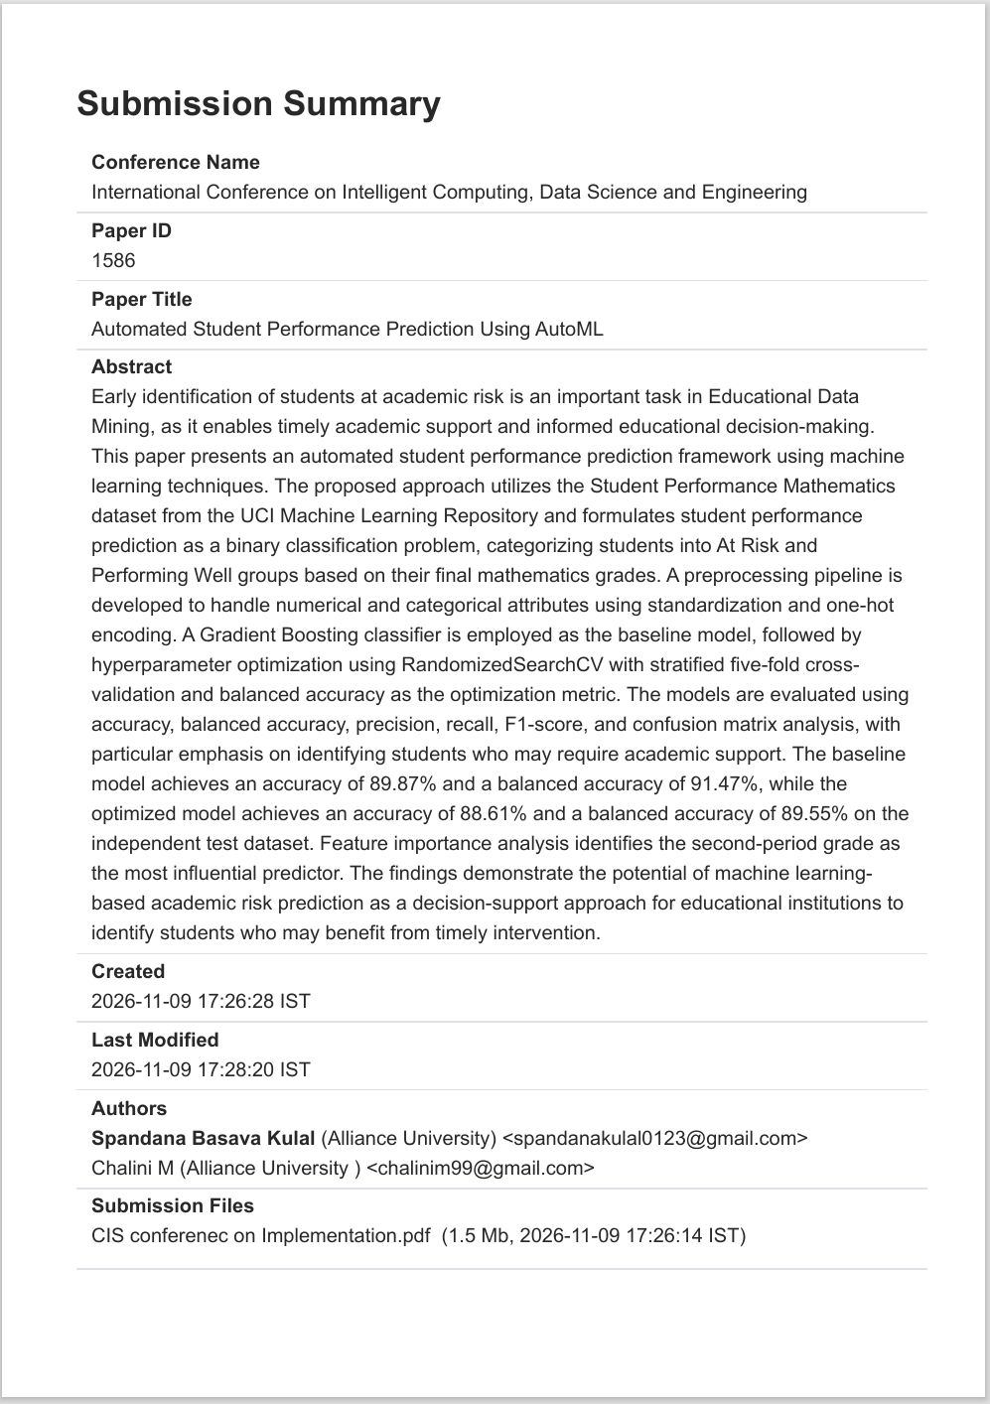
APPENDIX_B – CONFERENCE SUBMISSION SUMMARY

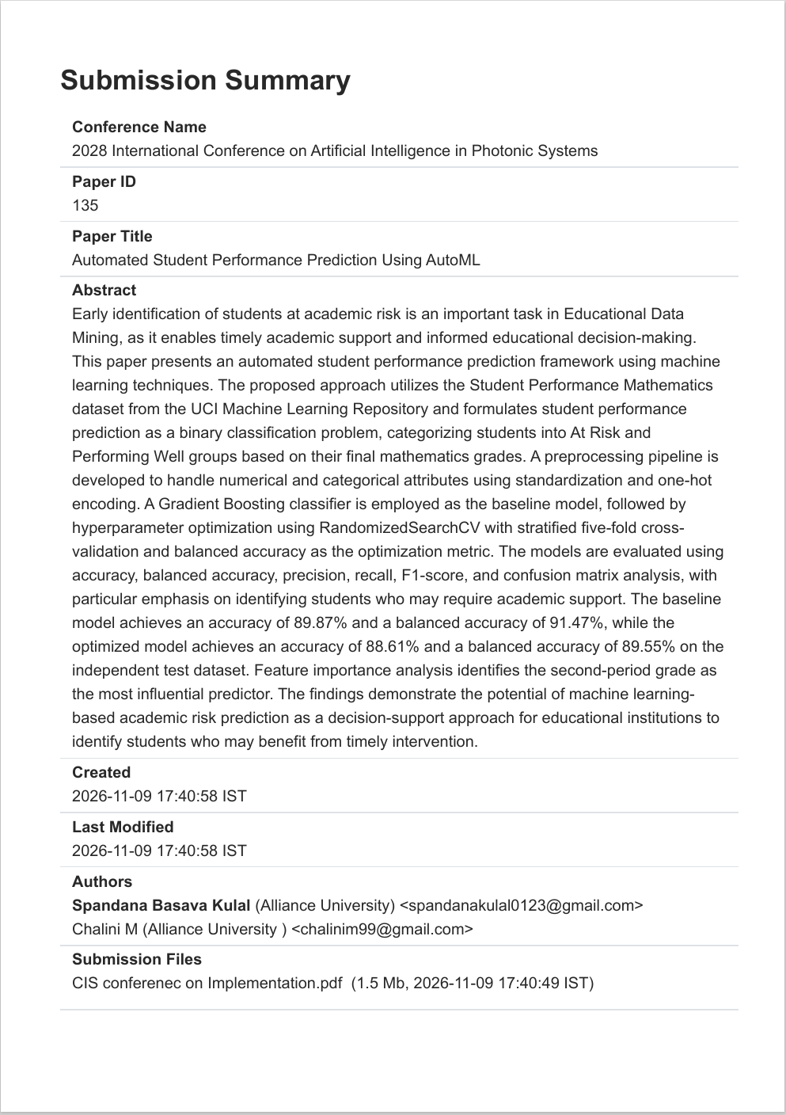

APPENDIX_C – SOURCE CODE
A.1 Importing Required Libraries
import pandas as pd
import numpy as np
import optuna
import joblib
from sklearn.model_selection import (
train_test_split,
StratifiedKFold,
cross_val_score
from sklearn.compose import ColumnTransformer
from sklearn.preprocessing import (
StandardScaler,
OneHotEncoder
from sklearn.pipeline import Pipeline
from sklearn.impute import SimpleImputer
from sklearn.linear_model import LogisticRegression
from sklearn.tree import DecisionTreeClassifier
from sklearn.ensemble import RandomForestClassifier
from sklearn.svm import SVC
from xgboost import XGBClassifier
from sklearn.metrics import (
accuracy_score,
precision_score,
recall_score,
f1_score,
balanced_accuracy_score,
confusion_matrix,
classification_report)
import warnings
warnings.filterwarnings("ignore")
A.2 Dataset Loading
math_data = pd.read_csv(
"student-mat.csv",
sep=";")
portuguese_data = pd.read_csv(
"student-por.csv",
sep=";")
print("Mathematics Dataset:", math_data.shape)
print("Portuguese Dataset:", portuguese_data.shape)
print(math_data.head())
print(portuguese_data.head())
A.3 Data Preprocessing and Target Creation
def prepare_dataset(data, scenario):
data = data.copy()
# Remove duplicate records
data = data.drop_duplicates()
# Create binary target variable
data["Performance"] = (
data["G3"] >= 10
).astype(int)
# Select features based on prediction scenario
if scenario == "Early Prediction":
X = data.drop(
columns=["G1", "G2", "G3", "Performance"])
elif scenario == "Grade-Assisted Prediction":
X = data.drop(
columns=["G3", "Performance"] )
else:
raise ValueError("Invalid prediction scenario")
y = data["Performance"]
return X, y
A.4 Feature Transformation
def create_preprocessor(X):
numerical_features = X.select_dtypes(
include=["int64", "float64"]
).columns.tolist()
categorical_features = X.select_dtypes(
include=["object"]
).columns.tolist()
numerical_pipeline = Pipeline([
("imputer", SimpleImputer(strategy="median")),
("scaler", StandardScaler()) ])
categorical_pipeline = Pipeline([
("imputer", SimpleImputer(strategy="most_frequent")),
("encoder", OneHotEncoder(
handle_unknown="ignore"))])
preprocessor = ColumnTransformer([
("numerical", numerical_pipeline, numerical_features),
("categorical", categorical_pipeline, categorical_features) ])
return preprocessor
A.5 Machine Learning Model Selection
def get_model(model_name, trial=None):
if model_name == "Logistic Regression":
return LogisticRegression(
C=trial.suggest_float("C", 0.01, 10.0, log=True)
if trial else 1.0,
class_weight="balanced",
max_iter=2000)
elif model_name == "Decision Tree":
return DecisionTreeClassifier(
max_depth=trial.suggest_int("max_depth", 3, 20)
if trial else None,
class_weight="balanced",
random_state=42 )
elif model_name == "Random Forest":
return RandomForestClassifier(
n_estimators=trial.suggest_int(
"n_estimators", 100, 500
) if trial else 200,
max_depth=trial.suggest_int(
"max_depth", 3, 20
) if trial else None,
class_weight="balanced",
random_state=42)
elif model_name == "SVM":
return SVC(
C=trial.suggest_float("C", 0.1, 10.0, log=True)
if trial else 1.0,
kernel="rbf",
class_weight="balanced",
probability=True)
elif model_name == "XGBoost":
return XGBClassifier(
n_estimators=trial.suggest_int(
"n_estimators", 100, 500
) if trial else 200,
max_depth=trial.suggest_int(
"max_depth", 3, 10
) if trial else 5,
learning_rate=trial.suggest_float(
"learning_rate", 0.01, 0.3
) if trial else 0.1,
eval_metric="logloss",
random_state=42)
else:
raise ValueError("Unknown model")
A.6 Optuna Hyperparameter Optimization
def optimize_model(model_name, X_train, y_train):
preprocessor = create_preprocessor(X_train)
cv = StratifiedKFold(
n_splits=5,
shuffle=True,
random_state=42)
def objective(trial):
classifier = get_model(model_name, trial)
pipeline = Pipeline([
("preprocessor", preprocessor),
("classifier", classifier) ])
scores = cross_val_score(
pipeline,
X_train,
y_train,
cv=cv,
scoring="f1_macro",
n_jobs=-1 )
return scores.mean()
study = optuna.create_study(
direction="maximize",
sampler=optuna.samplers.TPESampler(seed=42))
study.optimize(
objective,
n_trials=50)
return study.best_params, study.best_value
A.7 Model Training and Evaluation
def train_and_evaluate(
model_name,
X_train,
X_test,
y_train,
y_test,
best_params):
preprocessor = create_preprocessor(X_train)
if model_name == "XGBoost":
classifier = XGBClassifier(
**best_params,
eval_metric="logloss",
random_state=42 )
elif model_name == "Random Forest":
classifier = RandomForestClassifier(
**best_params,
class_weight="balanced",
random_state=42)
elif model_name == "Decision Tree":
classifier = DecisionTreeClassifier(
**best_params,
class_weight="balanced",
random_state=42 )
elif model_name == "Logistic Regression":
classifier = LogisticRegression(
**best_params,
class_weight="balanced",
max_iter=2000)
else:
classifier = SVC(
**best_params,
kernel="rbf",
class_weight="balanced",
probability=True )

pipeline = Pipeline([
("preprocessor", preprocessor),
("classifier", classifier) ])
pipeline.fit(X_train, y_train)
predictions = pipeline.predict(X_test)
results = {
"Accuracy": accuracy_score(y_test, predictions),
"Precision": precision_score(
y_test, predictions, zero_division=0 ),
"Recall": recall_score(
y_test, predictions, zero_division=0),
"F1 Score": f1_score(
y_test, predictions, zero_division=0),
"Macro-F1": f1_score(
y_test, predictions,
average="macro",
zero_division=0 ),
"Balanced Accuracy": balanced_accuracy_score(
y_test, predictions) }
print("Model:", model_name)
print(results)
print(confusion_matrix(y_test, predictions))
return pipeline, results
A.8 Model Serialization Using Joblib
# Save the trained model pipeline
joblib.dump(
best_model,
"student_performance_model.pkl")
# Load the saved model
loaded_model = joblib.load(
"student_performance_model.pkl")
print("Model loaded successfully")
A.9 Student Performance Prediction
def predict_student_performance(model, student_data):
prediction = model.predict(student_data)

probabilities = model.predict_proba(student_data)
if prediction[0] == 1:
result = "Pass"
else:
result = "Fail"
confidence = max(probabilities[0]) * 100
return result, confidence
A.10 Streamlit Dashboard
import streamlit as st
import pandas as pd
import joblib
st.set_page_config(
page_title="Student Performance Prediction",
layout="wide")
st.title("Automated Student Performance Prediction")
st.write(
"An AutoML-based system for predicting student "
"academic performance.")
subject = st.selectbox(
"Select Subject",
["Mathematics", "Portuguese"])
scenario = st.selectbox(
"Select Prediction Scenario",
["Early Prediction", "Grade-Assisted Prediction"])
st.subheader("Student Information")
student_file = st.file_uploader(
"Upload student input data",
type=["csv"])
if student_file is not None:
student_data = pd.read_csv(student_file)
st.write("Student Input Data")
st.dataframe(student_data)
if st.button("Predict Performance"):
model_path = (
f"models/{subject.lower()}_"
f"{scenario.lower().replace(' ', '_')}.pkl" )
model = joblib.load(model_path)
predictions = model.predict(student_data)
probabilities = model.predict_proba(student_data)
output = student_data.copy()
output["Prediction"] = [
"Pass" if value == 1 else "Fail"
for value in predictions]
output["Confidence"] = probabilities.max(axis=1) * 100
st.subheader("Prediction Results")
st.dataframe(output)
st.success("Prediction completed successfully.")
A.11 Execution of the Prediction Framework
# Dataset configuration
datasets = {
"Mathematics": math_data,
"Portuguese": portuguese_data}
scenarios = [
"Early Prediction",
"Grade-Assisted Prediction"]
models = [
"Logistic Regression",
"Decision Tree",
"Random Forest",
"SVM",
"XGBoost"]
random_seeds = [42, 43, 44]
# Iterate through datasets and scenarios
for subject, dataset in datasets.items():
for scenario in scenarios:
print("\nSubject:", subject)
print("Scenario:", scenario)
X, y = prepare_dataset(dataset, scenario)
X_train, X_test, y_train, y_test = train_test_split(
X,
y,
test_size=0.20,
stratify=y,
random_state=42 )
for model_name in models:
print("\nEvaluating:", model_name)
best_params, best_score = optimize_model(
model_name,
X_train,
y_train)
best_model, metrics = train_and_evaluate(
model_name,
X_train,
X_test,
y_train,
y_test,
best_params)
print("Best CV Macro-F1:", best_score)

RFERENCES & BIBLIOGRAPHY
- S. Ariponnammal and S. Natrajan, “Transport Phenomena of Semiconductors,” Journal of Medical Physics, Vol. 42, No 5, pp. 421-425, May 2005
- P. Banerjee, M. Haldar, D. Zaertsky and R. Anderson, “Overview of 4 Compiler for Synthesizing Matlab Programs onto FPGAs,” IEEE Transactions on Very Large Scale Integration (VLSI) System, Vol. 12, No 3, pp. 312-324, March 2004
- J. Jores (2006), “Contact Mechanics,” Cambridge University Press, UK, Chapter 6, pp. 144-164
- C. Rovers Eds., “Recent Advances in DSP Techniques,” 2nd ed., Taylors Frances Group, USA 2006
- R. Smith (2008), “Contact of Cylindrical Surfaces”. Available Online at: http://www.casphy.cenm.edu/homepage.html
- H. D. Cheng, “Image Features Extraction using Volterra Filters,” Proc. of 5th IEEEInternational Conference on Machine Vision and Artificial Intelligence, China, pp42-57, October 2009
- A. K. Barnard, “A Study of Stereo Matching Algorithms for Mobile Robots,” A Thesis Report for University of Bath, U.K., 2005
- J. P. Williamson, “Non-Linear Resonant Granit Devices,” US Patent 3 624 12, July 16, 1990
- Motorola Semiconductor Data Manual, Motorola Semiconductor Products Inc., Phoenix, AZ, 1987
- Motorola Semiconductor Data Manual, Motorola Semiconductor Products Inc., Phoenix, AZ, 1987
- Motorola Semiconductor Data Manual, Motorola Semiconductor Products Inc., Phoenix, AZ, 1987
- Motorola Semiconductor Data Manual, Motorola Semiconductor Products Inc., Phoenix, AZ, 1987
- Motorola Semiconductor Data Manual, Motorola Semiconductor Products Inc., Phoenix, AZ, 1987
- Motorola Semiconductor Data Manual, Motorola Semiconductor Products Inc., Phoenix, AZ, 1987
- Motorola Semiconductor Data Manual, Motorola Semiconductor Products Inc., Phoenix, AZ, 1987.

